Initial Screen

Step 1:

Select required JSON File

Step 2:

The application load the JSON file and update UI controllers.

Step 4:

Click on Start button to perform calculations

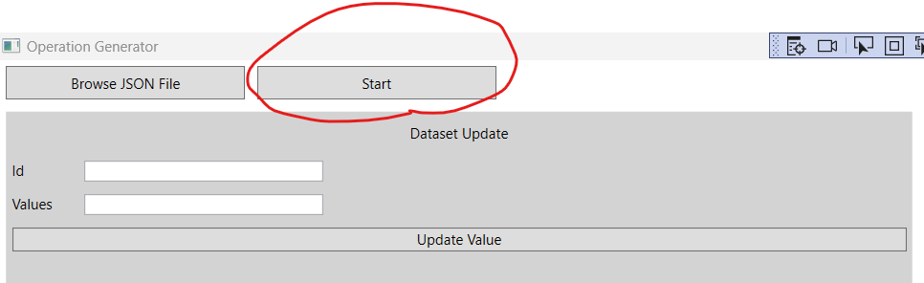

All the calculations results will be updated

Update Dataset and Generator Values

Select row from the DataGrid, the appropriate text boxes updated with the value. You can change the value and the result automatically reflected on the next cycle.

The same for Generator

